**Bonus Exercise 1**

Algoritm

|  |
| --- |
| START  WeekDay = 0 , WeekendDay = 0  input GearType , TotalRentDay  FOR num = 1 TO TotalRentDay  input Day  IF Day == "Saturday" || Day == "Sunday" THEN  IF Gear Type == "Basic Tent" THEN  RatePerDay = 25 + 8  ELSE IF Gear Type == "Advanced Tent" THEN  RatePerDay = 50 + 15  ELSE IF Gear Type == "Backpack" THEN  RatePerDay = 15 + 5  ENDIF  WeekendDay = WeekendDay ++  TotalWeekendCost = RatePerDay * WeekendDay  ELSE  IF Gear Type == "Basic Tent" THEN  RatePerDay = 25  ELSE IF Gear Type == "Advanced Tent" THEN  RatePerDay = 50  ELSE IF Gear Type == "Backpack" THEN  RatePerDay = 15  ENDIF  WeekDay = WeekDay ++  TotalWeekDayCost = RatePerDay * WeekDay  ENDIF  ENDFOR  TotalRentalCost = TotalWeekDayCost + TotalWeekendCost  END |

Flowchart

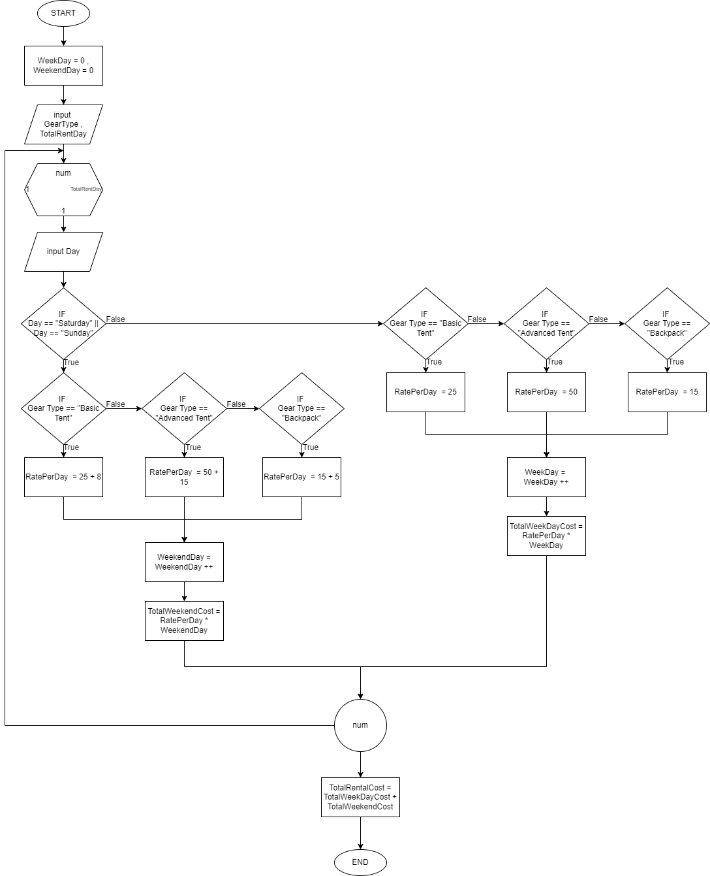

**Bonus Exercise 2**

**Question 1**

|  |
| --- |
| PRINT(NunmbeR_Of_DaY , EnerY_PeR_DaY , TotaL_CumulativE_EnergY)  FOR NuM = 1 TO NunmbeR_Of_DaY  Display "Energy consumption for day " , NuM , EnerY_PeR_DaY  ENDFOR  Display "Total cumulative energy consumption for " , NunmbeR_Of_DaY , TotaL_CumulativE_EnergY  EXIT  CALCULATE(POWER_RATING , HOURS_USED , NUMBER_OF_DAY , *ENERGY_PER_DAY)  TOTAL_CUMULATIVE_ENERGY = 0  IF POWER_RATING < 500 THEN  HOURS_USED_RATE = 1.5  ELSE IF POWER_RATING >= 500 && POWER_RATING <= 1500 THEN  HOURS_USED_RATE = 3.0  ELSE IF POWER_RATING > 1500 THEN  HOURS_USED_RATE = 5.0  ENDIF  *ENERGY_PER_DAY = HOURS_USED_RATE * HOURS_USED  FOR num = 1 TO NUMBER_OF_DAY  TOTAL_CUMULATIVE_ENERGY = TOTAL_CUMULATIVE_ENERGY + *ENERGY_PER_DAY  ENDFOR  PRINT(NUMBER_OF_DAY , *ENERGY_PER_DAY , TOTAL_CUMULATIVE_ENERGY)  EXIT  READ(power_rating , hours_used , number_of_day , *energy_per_day)  IF power_rating > 100 && power_rating < 3000 THEN  CALCULATE (power_rating , hours_used , number_of_day , energy_per_day)  ELSE  display Error message  ENDIF  EXIT  START  EnergyPerDay = 0  DO  input PowerRating , HoursUsed , NumberOfDay  READ(PowerRating , HoursUsed , NumberOfDay , &EnergyPerDay)  WHILE EnergyPerDay == 0.00  END |

**Question 2**

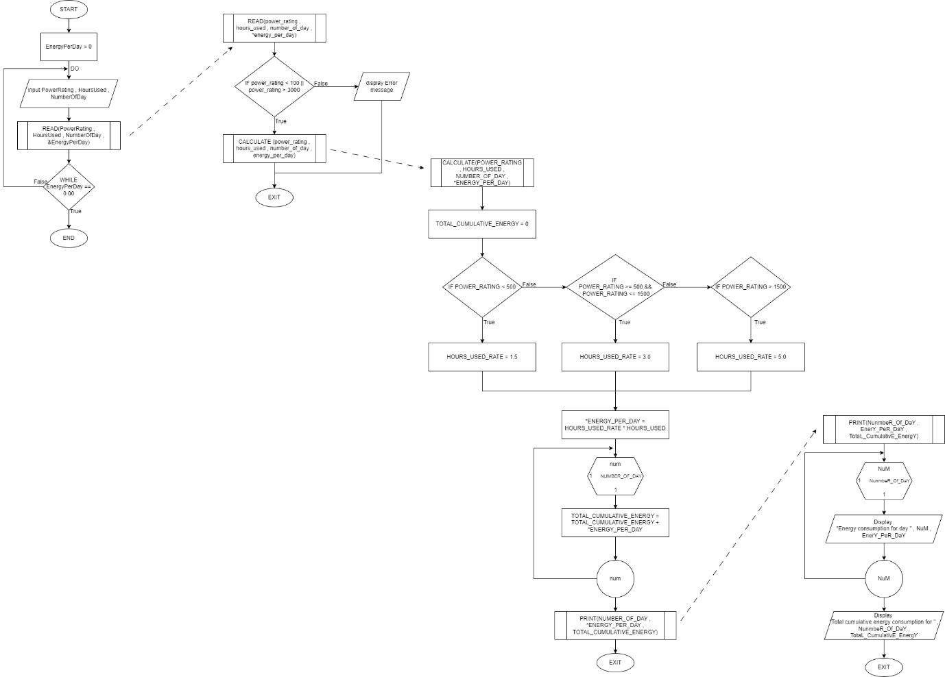

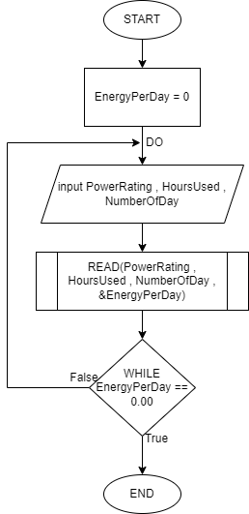 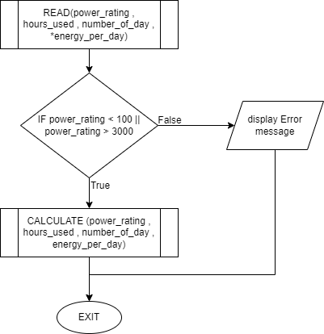

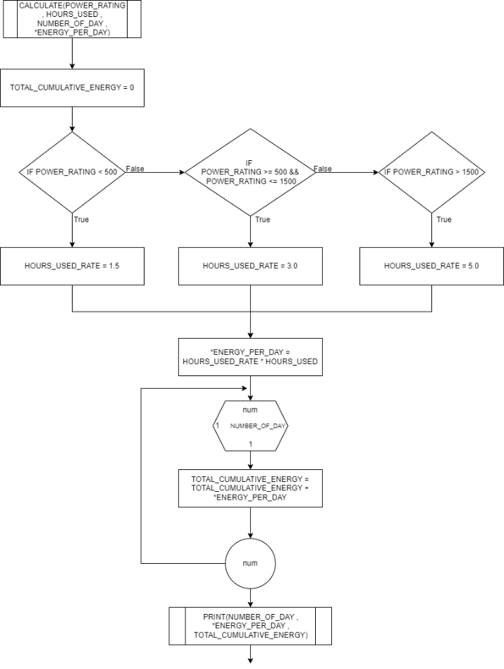 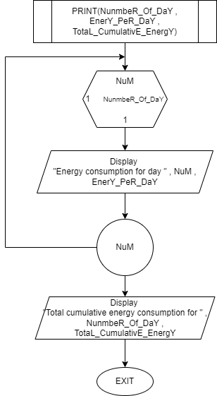

**Question 3**

Codding Base on algorihm in Question 1 (With Module)

|  |
| --- |
| //CB24019 - PUTERA NAQIB KHUSAIRI BIN ASRI  #include <stdio.h>  #include <string.h>  void print(int NumbeR_Of_DaY ,float EnerY_PeR_DaY ,float TotaL_CumulativE_EnergY)  {  for(int NuM = 1; NuM <= NumbeR_Of_DaY ; NuM++)  {  printf("\nEnergy consumption for day %d: %.1f kWh", NuM , EnerY_PeR_DaY);  }  printf("\nTotal cumulative energy consumption for %d days: %.1f kWh\n", NumbeR_Of_DaY , TotaL_CumulativE_EnergY);  }  void calculate(int POWER_RATING ,int HOURS_USED ,int NUMBER_OF_DAY ,float *ENERGY_PER_DAY)  {  float TOTAL_CUMULATIVE_ENERGY = 0 , HOURS_USED_RATE;  if(POWER_RATING < 500)  {  HOURS_USED_RATE = 1.5;  }  else if(POWER_RATING >= 500 && POWER_RATING <= 1500)  {  HOURS_USED_RATE = 3.0;  }  else if(POWER_RATING > 1500)  {  HOURS_USED_RATE = 5.0;  }  *ENERGY_PER_DAY = HOURS_USED_RATE * HOURS_USED;  for(int num = 1; num <= NUMBER_OF_DAY; num++)  {  TOTAL_CUMULATIVE_ENERGY = TOTAL_CUMULATIVE_ENERGY + *ENERGY_PER_DAY;  }  print(NUMBER_OF_DAY , *ENERGY_PER_DAY , TOTAL_CUMULATIVE_ENERGY);  }  void read(int power_rating ,int hours_used ,int number_of_day ,float *energy_per_day , char name[250] , char address [250] , char mobile_no [250])  {  if(power_rating > 100 && power_rating < 3000)  {  calculate(power_rating , hours_used , number_of_day , energy_per_day);  }  else  {  printf("Please Insert power rating between 100 and 3000 only\n");  system("pause");  system("cls");  printf("Name: %s\n",name);  printf("Address: %s\n",address);  printf("Mobile No: %s\n",mobile_no);  }  }  int main()  {  char Name[250] , Address [250] , MobileNo [250];  int PowerRating , HoursUsed , NumberOfDay;  float EnergyPerDay;  printf("Name: ");  gets(&Name);  printf("Address: ");  gets(&Address);  printf("Mobile No: ");  gets(&MobileNo);  do  {  printf("\nEnter power rating for appliance (W): ");  scanf("%d",&PowerRating);  printf("Enter number of hours used per day: ");  scanf("%d", &HoursUsed);  printf("Enter number of days: ");  scanf("%d", &NumberOfDay);  read(PowerRating , HoursUsed , NumberOfDay , &EnergyPerDay , Name , Address , MobileNo);  }  while(EnergyPerDay == 0.00);  printf("Thank you");  return 0;  } |

Codding Not Base on algorihm in Question 12 (Without Module)

|  |
| --- |
| //CB24019 - PUTERA NAQIB KHUSAIRI BIN ASRI  #include <stdio.h>  #include <string.h>  int main()  {  char Name[250] , Address [250] , MobileNo [250];  int PowerRating , HoursUsed , NumberOfDay;  float EnergyPerDay , TotalCumlativeEnergy = 0 , HoursUsedRate;  printf("Name: ");  gets(&Name);  printf("Address: ");  gets(&Address);  printf("Mobile Number: ");  gets(&MobileNo);  do  {  printf("\nEnter power rating for appliance (W): ");  scanf("%d",&PowerRating);  printf("Enter number of hours used per day: ");  scanf("%d", &HoursUsed);  printf("Enter number of days: ");  scanf("%d", &NumberOfDay);  if(PowerRating > 100 && PowerRating < 3000)  {  if(PowerRating < 500)  {  HoursUsedRate = 1.5;  }  else if(PowerRating >= 500 && PowerRating <=1500)  {  HoursUsedRate = 3.0;  }  else if(PowerRating > 1500)  {  HoursUsedRate = 5.0;  }  EnergyPerDay = HoursUsedRate * HoursUsed;  for(int num = 1; num <= NumberOfDay; num++)  {  TotalCumlativeEnergy = TotalCumlativeEnergy + EnergyPerDay;  }  printf("\nTotal Energy Consumption: %.1f kWh\n", TotalCumlativeEnergy);  }  else  {  printf("Please Insert power rating between 100 and 300 only\n");  system("pause");  system("cls");  printf("Name: %s\n",Name);  printf("Address: %s\n",Address);  printf("Mobile Number: %s\n",MobileNo);  }  }  while(EnergyPerDay == 0.00);  printf("Thank You");  return 0;  } |